What is Data?
- In simple words, data can be facts related to any object in consideration.
- Raw facts and figures that can be processed to produce information.
- Data are the raw bits and pieces of information with no context.
- Data can be quantitative or qualitative.
- Quantitative data is numeric, the result of a measurement, count, or some other mathematical calculation.
- Qualitative data is descriptive. “Ruby Red,” the color of a 2013 Ford Focus, is an example of qualitative data.
- A number can be qualitative too: if I tell you my favorite number is 5, that is qualitative data because it is descriptive, not the result of a measurement or mathematical calculation.

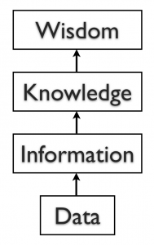
By itself, data is not that useful. To be useful, it needs to be given context.
Ex: - if I told you that “15, 23, 14, and 85″ are the numbers of students that had registered for upcoming classes, that would be information.
Once we have put our data into context, aggregated and analyzed it, we can use it to make decisions for our organization.
We can say that this consumption of information produces knowledge. This knowledge can be used to make decisions, set policies, and even spark innovation.
The final step up the information ladder is the step from knowledge (knowing a lot about a topic) to wisdom.
We can say that someone has wisdom when they can combine their knowledge and experience to produce a deeper understanding of a topic.
It often takes many years to develop wisdom on a particular topic and requires patience.

File System
- A file can be understood as a container to store data in a computer.
- Files can be stored on the storage device of a computer system. Contents of a file can be texts, computer program code, comma separated values
- Likewise, pictures, audios/videos, web pages are also files. Files stored on a computer can be accessed directly and searched for desired data.
- But to access data of a file through software, for example, to display monthly attendance report on school website, one has to write computer programs to access data from files.

Limitations of a File System
File system becomes difficult to handle when number of files increases and volume of data also grows. Following are some of the limitations of file system:
(A) Difficulty in Access - Files themselves do not provide any mechanism to retrieve data. Data maintained in a file system are accessed through application programs. While writing such programs, the developer may not anticipate all the possible ways in which data may be accessed. So, sometimes it is difficult to access data in the required format and one has to write application program to access data.
(B) Data Redundancy - Redundancy means same data are duplicated in different places (files). For ex:- if students with roll numbers 3 and 5 have same guardian name and therefore same guardian name is maintained twice. These are examples of redundancy which is difficult to avoid in a file system. Redundancy leads to excess storage use and may cause data inconsistency also.
(C) Data Inconsistency - Data inconsistency occurs when same data maintained in different places do not match.
If a student wants to get changed the spelling of her name, it needs to be maintained in Attendance and Student file as well. Likewise, if a student leaves school, the details need to be deleted from both the files. As the files are being maintained by different people, the changes may not happen in one of the files. In that case, the student name will be different (inconsistent) in both the files.
(D) Data Isolation - The school will have to write separate programs to access these two files. This is because data mapping is not supported in file system. In a more complex system where data files are generated by different person at different times, files being created in isolation may be of different formats. In such case, it is difficult to write new application programs to retrieve data from different files maintained at multiple places, as one has to understand the underlying structure of each file as well.
(E) Data Dependence - Data are stored in a specific format or structure in a file. If the structure or format itself is changed, all the existing application programs accessing that file also need to be change. Otherwise, the programs may not work correctly. This is data dependency. Hence, updating the structure of a data file requires modification in all the application programs accessing that file.
(F) Controlled Data Sharing - There can be different category of users like teacher, office staff and parents. Ideally, not every user should be able to access all the data. As an example, guardians and office staff can only see the student attendance data but should not be able to modify/delete it. It means these users should be given limited access (read only) to the ATTENDANCE file. Only the teacher should be able to update the attendance data. It is very difficult to enforce this kind of access control in a file system while accessing files through application programs.

What is Database?
A database is a systematic collection of data. They support electronic storage and manipulation of data. Databases make data management easy.
Let us discuss a database example: An online telephone directory uses a database to store data of people, phone numbers, and other contact details. Your electricity service provider uses a database to manage billing, client-related issues, handle fault data, etc.

What is Metadata?

The term metadata can be understood as “data about data.” example of metadata could be for an MP3 music file, like the one shown in the image below; information such as the length of the song, the artist, the album, the file size, and even the album cover art, are classified as metadata.
When a database is being designed, a “data dictionary” is created to hold the metadata, defining the fields and structure of the database.

Types of Databases
Here are some popular types of databases.

Distributed databases:
A distributed database is a type of database that has contributions from the common database and information captured by local computers. In this type of database system, the data is not in one place and is distributed at various organizations.
What is Database SQL

Relational databases:
This type of database defines database relationships in the form of tables. It is also called Relational DBMS, which is the most popular DBMS type in the market. Database example of the RDBMS system include MySQL, Oracle, and Microsoft SQL Server database.

Object-oriented databases:
This type of computers database supports the storage of all data types. The data is stored in the form of objects. The objects to be held in the database have attributes and methods that define what to do with the data. PostgreSQL is an example of an object-oriented relational DBMS.

Centralized database:
It is a centralized location, and users from different backgrounds can access this data. This type of computers databases store application procedures that help users access the data even from a remote location.

Open-source databases:
This kind of database stored information related to operations. It is mainly used in the field of marketing, employee relations, customer service, of databases.

NoSQL databases:
NoSQL database is used for large sets of distributed data. There are a few big data performance problems that are effectively handled by relational databases. This type of computers database is very efficient in analyzing large-size unstructured data.

Graph databases:
A graph-oriented database uses graph theory to store, map, and query relationships. These kinds of computers databases are mostly used for analyzing interconnections. For example, an organization can use a graph database to mine data about customers from social media.

Database Components
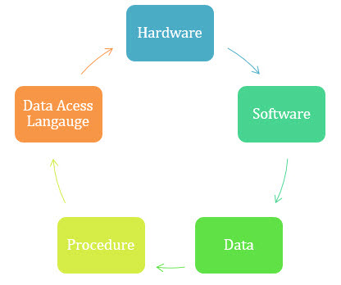
Database Components
There are five main components of a database:

Hardware:
The hardware consists of physical, electronic devices like computers, I/O devices, storage devices, etc. This offers the interface between computers and real-world systems.

Software:
This is a set of programs used to manage and control the overall database. This includes the database software itself, the Operating System, the network software used to share the data among users, and the application programs for accessing data in the database.

Data:
Data is a raw and unorganized fact that is required to be processed to make it meaningful. Data can be simple at the same time unorganized unless it is organized. Generally, data comprises facts, observations, perceptions, numbers, characters, symbols, images, etc.

Procedure:
Procedure are a set of instructions and rules that help you to use the DBMS. It is designing and running the database using documented methods, which allows you to guide the users who operate and manage it.

Database Access Language:
Database Access language is used to access the data to and from the database, enter new data, update already existing data, or retrieve required data from DBMS. The user writes some specific commands in a database access language and submits these to the database.

What is a Database Management System (DBMS)?
DBMS stands for Database Management System.
DBMS = Database + Management System.
Database is a collection of data and Management System is a set of programs to store and retrieve those data.
DBMS is a collection of inter-related data and set of programs to store & access those data in an easy and effective manner.
What is the need of DBMS?
Database systems are basically developed for large amount of data. When dealing with huge amount of data, there are two things that require optimization: Storage of data and retrieval of data.
Storage: According to the principles of database systems, the data is stored in such a way that it acquires lot less space as the redundant data (duplicate data) has been removed before storage.
Let’s take a layman example to understand this:
In a banking system, suppose a customer is having two accounts, one is saving account and another is salary account. Let’s say bank stores saving account data at one place (these places are called tables we will learn them later) and salary account data at another place, in that case if the customer information such as customer name, address etc. are stored at both places then this is just a wastage of storage (redundancy/ duplication of data), to organize the data in a better way the information should be stored at one place and both the accounts should be linked to that information somehow. The same thing we achieve in DBMS.
Fast Retrieval of data: Along with storing the data in an optimized and systematic manner, it is also important that we retrieve the data quickly when needed. Database systems ensure that the data is retrieved as quickly as possible.

Database Applications – DBMS
Applications where we use Database Management Systems are:
- Telecom: There is a database to keeps track of the information regarding calls made, network usage, customer details etc. Without the database systems it is hard to maintain that huge amount of data that keeps updating every millisecond.
- Banking System: For storing customer info, tracking day to day credit and debit transactions, generating bank statements etc. All this work has been done with the help of Database management systems.
- Sales: To store customer information, production information and invoice details.
- Airlines: To travel though airlines, we make early reservations, this reservation information along with flight schedule is stored in database.
- Education sector: Database systems are frequently used in schools and colleges to store and retrieve the data regarding student details, staff details, course details, exam details, payroll data, attendance details, fees details etc. There is a hell lot amount of inter-related data that needs to be stored and retrieved in an efficient manner.
- Online shopping: You must be aware of the online shopping websites such as Amazon, Flipkart etc. These sites store the product information, your addresses and preferences, credit details and provide you the relevant list of products based on your query. All this involves a Database management system.

Advantage of DBMS over file system
There are several advantages of Database management system over file system. Few of them are as follows:
- No redundant data: Redundancy removed by data normalization. No data duplication saves storage and improves access time.
- Data Consistency and Integrity: As we discussed earlier the root cause of data inconsistency is data redundancy, since data normalization takes care of the data redundancy, data inconsistency also been taken care of as part of it
- Data Security: It is easier to apply access constraints in database systems so that only authorized user can access the data. Each user has a different set of access thus data is secured from the issues such as identity theft, data leaks and misuse of data.
- Privacy: Limited access means privacy of data.
- Easy access to data – Database systems manages data in such a way so that the data is easily accessible with fast response times.
- Easy recovery: Since database systems keeps the backup of data, it is easier to do a full recovery of data in case of a failure.
- Flexible: Database systems are more flexible than file processing systems.
Disadvantages of DBMS:
- Cost
- Complexity
- Size
Different Types of Database Users in DBMS

Application Programmers
As its name shows, application programmers are the one who writes application programs that uses the database. These application programs are written in programming languages like COBOL or PL (Programming Language 1), Java and fourth generation language. These programs meet the user requirement and made according to user requirements. Retrieving information, creating new information and changing existing information is done by these application programs.

They interact with DBMS through DML (Data manipulation language) calls. And all these functions are performed by generating a request to the DBMS. If application programmers are not there then there will be no creativity in the whole team of Database.

End Users
End users are those who access the database from the terminal end. They use the developed applications and they don’t have any knowledge about the design and working of database. These are the second class of users and their main motto is just to get their task done.

DBA (Database Administrator)
DBA can be a single person, or it can be a group of person. Database Administrator is responsible for everything that is related to database. He makes the policies, strategies and provides technical supports.

Data Model
- Data Model is a logical structure of Database. It describes the design of database to reflect entities, attributes, relationship among data, constrains etc.
- It defines the data elements and the relationships between the data elements.
- Data Models are used to show how data is stored, connected, accessed and updated in the database management system.

Some of the Data Models in DBMS are:
- Hierarchical Model
- Network Model
- Entity-Relationship Model (ER-model)
- Relational Model
- Object-Oriented Data Model
- Object-Relational Data Model

Hierarchical Model
Hierarchical Model was the first DBMS model. This model organises the data in the hierarchical tree structure. The hierarchy starts from the root which has root data and then it expands in the form of a tree adding child node to the parent node. This model easily represents some of the real-world relationships like food recipes, sitemap of a website etc. Example: We can represent the relationship between the shoes present on a shopping website in the following way:
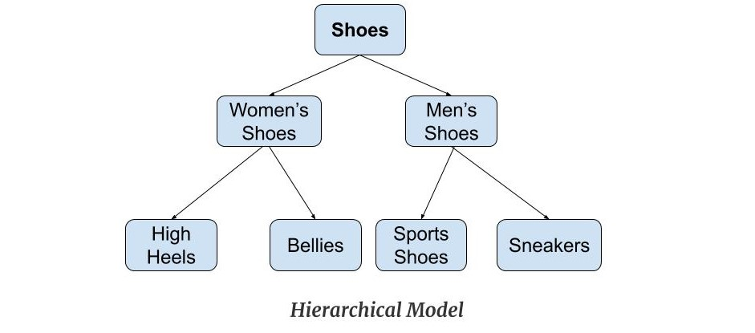
Features of a Hierarchical Model
One-to-many relationship: The data here is organised in a tree-like structure where the one-to-many relationship is between the datatypes. Also, there can be only one path from parent to any node. Example: In the above example, if we want to go to the node sneakers we only have one path to reach there i.e through men's shoes node.
Parent-Child Relationship: Each child node has a parent node but a parent node can have more than one child node. Multiple parents are not allowed.
Deletion Problem: If a parent node is deleted then the child node is automatically deleted.
Pointers: Pointers are used to link the parent node with the child node and are used to navigate between the stored data. Example: In the above example the 'shoes' node points to the two other nodes 'women shoes' node and 'men's shoes' node.

Advantages of Hierarchical Model
It is very simple and fast to traverse through a tree-like structure.
Any change in the parent node is automatically reflected in the child node so, the integrity of data is maintained.

Disadvantages of Hierarchical Model
Complex relationships are not supported.
As it does not support more than one parent of the child node so if we have some complex relationship where a child node needs to have two parent node then that can't be represented using this model.
If a parent node is deleted then the child node is automatically deleted.

Network Model
This model is an extension of the hierarchical model. It was the most popular model before the relational model. This model is the same as the hierarchical model, the only difference is that a record can have more than one parent. It replaces the hierarchical tree with a graph. Example: In the example below we can see that node student has two parents i.e. CSE Department and Library. This was earlier not possible in the hierarchical model.
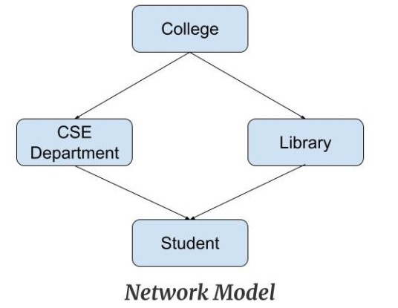
Features of a Network Model
Ability to Merge more Relationships: In this model, as there are more relationships so data is more related. This model has the ability to manage one-to-one relationships as well as many-to-many relationships.
Many paths: As there are more relationships so there can be more than one path to the same record. This makes data access fast and simple.
Circular Linked List: The operations on the network model are done with the help of the circular linked list. The current position is maintained with the help of a program and this position navigates through the records according to the relationship.

Advantages of Network Model
The data can be accessed faster as compared to the hierarchical model. This is because the data is more related in the network model and there can be more than one path to reach a particular node. So the data can be accessed in many ways.
As there is a parent-child relationship so data integrity is present. Any change in parent record is reflected in the child record.

Disadvantages of Network Model
As more and more relationships need to be handled the system might get complex. So, a user must be having detailed knowledge of the model to work with the model.
Any change like updation, deletion, insertion is very complex.

Entity-Relationship Model
Entity-Relationship Model or simply ER Model is a high-level data model diagram. In this model, we represent the real-world problem in the pictorial form to make it easy for the stakeholders to understand. It is also very easy for the developers to understand the system by just looking at the ER diagram. We use the ER diagram as a visual tool to represent an ER Model. ER diagram has the following three components:

Entities: Entity is a real-world thing. It can be a person, place, or even a concept. Example: Teachers, Students, Course, Building, Department, etc are some of the entities of a School Management System.

Attributes: An entity contains a real-world property called attribute. This is the characteristics of that attribute. Example: The entity teacher has the property like teacher id, salary, age, etc.

Relationship: Relationship tells how two or multiple entities are related. Example: Teacher works for a department.
Example:
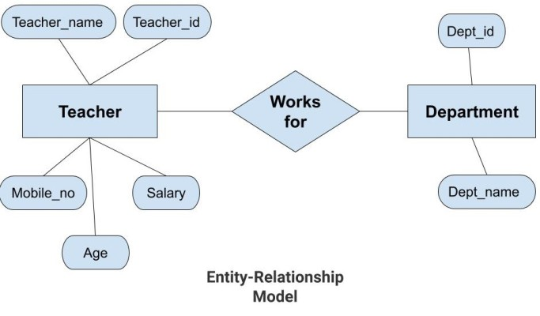
In the above diagram, the entities are Teacher and Department. The attributes of Teacher entity are Teacher_Name, Teacher_id, Age, Salary, Mobile_Number. The attributes of entity Department entity are Dept_id, Dept_name. The two entities are connected using the relationship. Here, each teacher works for a department.

Features of ER Model
Graphical Representation for Better Understanding: It is very easy and simple to understand so it can be used by the developers to communicate with the stakeholders.

ER Diagram: ER diagram is used as a visual tool for representing the model.

Advantages of ER Model
Simple: Conceptually ER Model is very easy to build. If we know the relationship between the attributes and the entities we can easily build the ER Diagram for the model.
Effective Communication Tool: This model is used widely by the database designers for communicating their ideas.
Easy Conversion to any Model: This model maps well to the relational model and can be easily converted relational model by converting the ER model to the table. This model can also be converted to any other model like network model, hierarchical model etc.

Disadvatages of ER Model
No industry standard for notation: There is no industry standard for developing an ER model. So one developer might use notations which are not understood by other developers.
Hidden information: Some information might be lost or hidden in the ER model. As it is a high-level view so there are chances that some details of information might be hidden.

Relational Model
Relational Model is the most widely used model. In this model, the data is maintained in the form of a two-dimensional table. All the information is stored in the form of row and columns. The basic structure of a relational model is tables. So, the tables are also called relations in the relational model. Example: In this example, we have an Employee table.
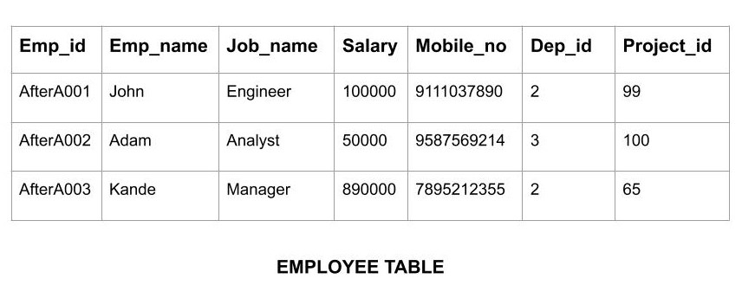
Features of Relational Model
Tuples: Each row in the table is called tuple. A row contains all the information about any instance of the object. In the above example, each row has all the information about any specific individual like the first row has information about John.
Attribute or field: Attributes are the property which defines the table or relation. The values of the attribute should be from the same domain. In the above example, we have different attributes of the employee like Salary, Mobile_no, etc.

Advnatages of Relational Model
Simple: This model is more simple as compared to the network and hierarchical model.
Scalable: This model can be easily scaled as we can add as many rows and columns we want.
Structural Independence: We can make changes in database structure without changing the way to access the data. When we can make changes to the database structure without affecting the capability to DBMS to access the data we can say that structural independence has been achieved.

Disadvantages of Relatinal Model
Hardware Overheads: For hiding the complexities and making things easier for the user this model requires more powerful hardware computers and data storage devices.
Bad Design: As the relational model is very easy to design and use. So the users don't need to know how the data is stored in order to access it. This ease of design can lead to the development of a poor database which would slow down if the database grows.
But all these disadvantages are minor as compared to the advantages of the relational model. These problems can be avoided with the help of proper implementation and organisation.

Object-Oriented Data Model
The real-world problems are more closely represented through the object-oriented data model. In this model, both the data and relationship are present in a single structure known as an object. We can store audio, video, images, etc in the database which was not possible in the relational model(although you can store audio and video in relational database, it is adviced not to store in the relational database). In this model, two are more objects are connected through links. We use this link to relate one object to other objects. This can be understood by the example given below.
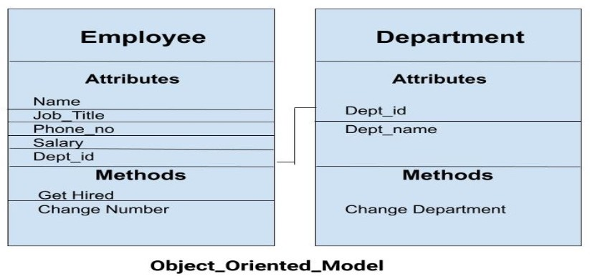
In the above example, we have two objects Employee and Department. All the data and relationships of each object are contained as a single unit. The attributes like Name, Job_title of the employee and the methods which will be performed by that object are stored as a single object. The two objects are connected through a common attribute i.e the Department_id and the communication between these two will be done with the help of this common id.

Object-Relational Model
As the name suggests it is a combination of both the relational model and the object-oriented model. This model was built to fill the gap between object-oriented model and the relational model. We can have many advanced features like we can make complex data types according to our requirements using the existing data types. The problem with this model is that this can get complex and difficult to handle. So, proper understanding of this model is required.

What is an Entity Relationship Diagram (ER Diagram)?
ER Diagram is a visual representation of data that describes how data is related to each other. In ER Model, we disintegrate data into entities, attributes and setup relationships between entities, all this can be represented visually using the ER diagram.
For example, in the below diagram, anyone can see and understand what the diagram wants to convey: Developer develops a website, whereas a Visitor visits a website.
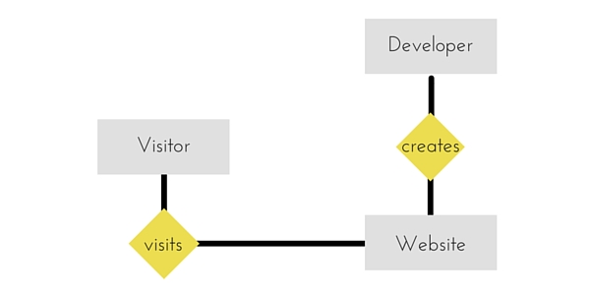

Entity
An entity can be a real-world object, either animate or inanimate, that can be easily identifiable. For example, in a school database, students, teachers, classes, and courses offered can be considered as entities. All these entities have some attributes or properties that give them their identity.
An entity set is a collection of similar types of entities. An entity set may contain entities with attribute sharing similar values. For example, a Students set may contain all the students of a school; likewise a Teachers set may contain all the teachers of a school from all faculties. Entity sets need not be disjoint.

Attributes
Entities are represented by means of their properties, called attributes. All attributes have values. For example, a student entity may have name, class, and age as attributes.
There exists a domain or range of values that can be assigned to attributes. For example, a student's name cannot be a numeric value. It has to be alphabetic. A student's age cannot be negative, etc.

Types of Attributes
- Simple attribute − Simple attributes are atomic values, which cannot be divided further. For example, a student's phone number is an atomic value of 10 digits.
- Composite attribute − Composite attributes are made of more than one simple attribute. For example, a student's complete name may have first_name and last_name.
- Derived attribute − Derived attributes are the attributes that do not exist in the physical database, but their values are derived from other attributes present in the database. For example, average_salary in a department should not be saved directly in the database, instead it can be derived. For another example, age can be derived from data_of_birth.
- Single-value attribute − Single-value attributes contain single value. For example − Social_Security_Number.
- Multi-value attribute − Multi-value attributes may contain more than one values. For example, a person can have more than one phone number, email_address, etc.

Relationship
The association among entities is called a relationship. For example, an employee works_at a department, a student enrolls in a course. Here, Works_at and Enrolls are called relationships.

Relationship Set
A set of relationships of similar type is called a relationship set. Like entities, a relationship too can have attributes. These attributes are called descriptive attributes.

Degree of Relationship
The number of participating entities in a relationship defines the degree of the relationship.
- Binary = degree 2
- Ternary = degree 3
- n-ary = degree

Cardinality of Relationship
Cardinality defines the number of entities in one entity set, which can be associated with the number of entities of other set via relationship set.
- One-to-one − One entity from entity set A can be associated with at most one entity of entity set B and vice versa.
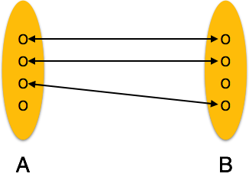
- One-to-many − One entity from entity set A can be associated with more than one entities of entity set B however an entity from entity set B, can be associated with at most one entity.
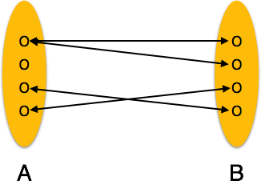
- Many-to-one − More than one entities from entity set A can be associated with at most one entity of entity set B, however an entity from entity set B can be associated with more than one entity from entity set A.
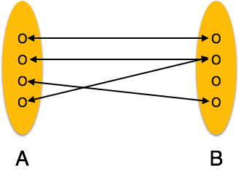
- Many-to-many − One entity from A can be associated with more than one entity from B and vice versa.
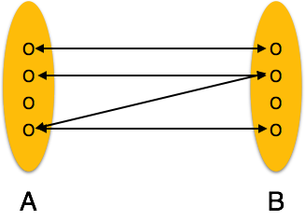

Let's see how we can represent these in our ER Diagram.

Entity
Simple rectangular box represents an Entity.
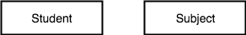

Relationships between Entities - Weak and Strong
Rhombus is used to setup relationships between two or more entities.
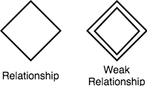

Attributes for any Entity
Ellipse is used to represent attributes of any entity. It is connected to the entity.
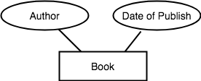

Weak Entity
A weak Entity is represented using double rectangular boxes. It is generally connected to another entity.
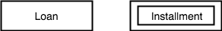

Key Attribute for any Entity
To represent a Key attribute, the attribute name inside the Ellipse is underlined.
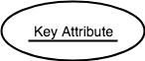

Derived Attribute for any Entity
Derived attributes are those which are derived based on other attributes, for example, age can be derived from date of birth.
To represent a derived attribute, another dotted ellipse is created inside the main ellipse.
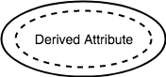

Multivalued Attribute for any Entity
Double Ellipse, one inside another, represents the attribute which can have multiple values.
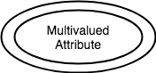

Composite Attribute for any Entity
A composite attribute is the attribute, which also has attributes.
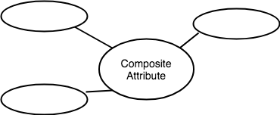

Table
A table is a collection of data represented in rows and columns. Each table has a name in database. For example, the following table “STUDENT” stores the information of students in database.
Table: STUDENT
Student_Id | Student_Name | Student_Addr | Student_Age
101 | Chaitanya | Dayal Bagh, Agra | 27
102 | Ajeet | Delhi | 26
103 | Rahul | Gurgaon | 24
104 | Shubham | Chennai | 25

Record or Tuple or Row
Each row of a table is known as record. It is also known as tuple. For example, the following row is a record that we have taken from the above table.
102 | Ajeet | Delhi | 26

Field or Column name or Attribute
The above table “STUDENT” has four fields (or attributes): Student_Id, Student_Name, Student_Addr & Student_Age.

Domain
A domain is a set of permitted values for an attribute in table.
For example, a domain of month-of-year can accept January, February,…December as values, a domain of dates can accept all possible valid dates etc. We specify domain of attribute while creating a table.
An attribute cannot accept values that are outside of their domains. For example, In the above table “STUDENT”, the Student_Id field has integer domain so that field cannot accept values that are not integers for example, Student_Id cannot has values like, “First”, 10.11 etc.

keys in DBMS
Key plays an important role in relational database; it is used for identifying unique rows from table. It also establishes relationship among tables.
Primary Key – A primary is a column or set of columns in a table that uniquely identifies tuples (rows) in that table. (No null and no duplicates )
Super Key – A super key is a set of one of more columns (attributes) to uniquely identify rows in a table.
Candidate Key – A super key with no redundant attribute is known as candidate key
Alternate Key – Out of all candidate keys, only one gets selected as primary key, remaining keys are known as alternate or secondary keys.
Unique Key – uniquely defines each row in a table.
Composite Key – A key that consists of more than one attribute to uniquely identify rows (also known as records & tuples) in a table is called composite key.
Foreign Key – Foreign keys are the columns of a table that points to the primary key of another table. They act as a cross-reference between tables.

The Client/Server Architecture
The client/server model of a database system is really very simple, but its meaning has evolved somewhat through popular usage. The client/server model is shown below.
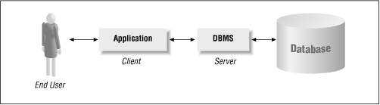
The client/server mode example
The server in a client/server model is simply the DBMS, whereas the client is the database application serviced by the DBMS. (We could also think of Visual Basic and Access as clients of the Jet DBMS server.)
The basic client/server model says nothing about the location of the various components. However, since the components are distinct, it is not uncommon to find them on different computers. The two most common configurations are illustrated below. The distributed client/server model , wherein the client is on one computer and the server and database are on another, is so popular that it is usually simply referred to as the client/server model. The remote database model refers to the case in which the client and server are on the same computer, but the database is on a remote computer.
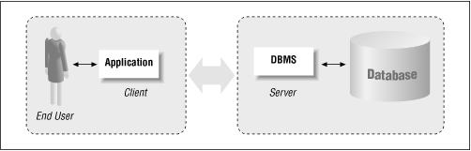
The distributed client/server model example
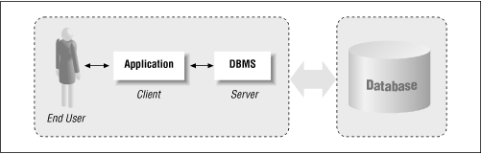
The remote database example

